EI Studio MVP Transition
ALICE

Table of Contents

1 Project Summary 5
1.1 Business Summary 5
2 Solution Design 6
2.1 Architecture Design 6
2.1.1 Data Requirements – Suggested Data Sources 6
2.1.2 MVP Architecture 6
2.1.3 Proposed Training Architecture 9
2.1.4 Proposed Execution Architecture 10
2.2 Pre- Processing 10
2.2.1 Overview 10
2.2.2 Data pipeline 10
2.2.3 Index 11
2.3 Clause Extraction 12
2.3.1 Introduction 12
2.3.2 Approach 12
2.3.3 Installation 12
2.3.4 Creating the word embedding model 13
2.3.5 Using the word embedding model for clause extraction 13
2.3.6 Refreshing the word embedding model 13
2.3.7 Evaluation 14
2.3.8 Adding and removing words to the keyword lists 14
2.3.9 Evaluation work before April release 14
2.3.10 Potential work for future releases 14
2.3.11 Bias 15
3 ALICE Front-End 16
3.1 Installation 16
3.1.1 Installation for Developers 16
3.1.2 Developer kits 17
3.2 Resources 17
3.2.1 Demonstration Environment 17
3.2.2 Repository 17
3.3 Structure Of Front-End 17
3.4 Features 19
3.5 How the front-end works with API 22
4 Studio Delivery Scope and Timeline 24
4.1 Scope 24
4.1.1 MVP Timeline 25
4.1.2 Production Timeline 25
5 MVP Deployment (Project Pilot) 26
6 Project Completion 27
6.1 Completion checklist 27
6.2 Completion Criteria 27
6.3 Data Usage 27
6.3.1 Data overview 27
6.3.2 Mapping between input tables for ALICE Metadata 28
7 Transition Communications 31
7.1 Communication with PO/Stakeholder 31
7.2 Transition Activities Agreed 31
8 Approvals 32
9 Appendix 33
9.1 Presentation and Stakeholder Slides 33
9.2 Technical Report and Blog 33
9.3 MVP Code Repository 33
9.4 Author of different sections 33

Version | Description | Date | Author
0.0 | Initial draft | 21/01/2019 | Jenny McCarthy
0.1 | Clause extraction v1 | 25/01/2019 | Aonghus McGovern
0.2 | Architecture section v1 | 30/01/2019 | Pranay Sanjay Shah
0.3 | Pre-processing v1 | 01/02/2019 | Anna Kostekidou
0.4 | UI update | 19/02/2019 | Bing A Zhao

Project Summary

Business Summary
Finding contracts and extracting relevant information from them is a tedious and expensive task. ALICE has been created to reduce the manual effort to extract information from contracts. It will also act as a contract search repository.
The aim of the ALICE project is:
- Cost savings - Manually searching through contracts for necessary information is information.
- Improve efficiency of legal when managing contracts.
- Reduce time to find necessary information in time sensitive scenarios i.e. business continuity plans.
- Use natural language processing to find synonyms for legal terms to extract the text for particular contract clauses.

Solution Design

Architecture Design

Data Requirements – Suggested Data Sources
Data transfer is expected to transfer from MMR application.
RAW Data sources:
- MMR metadata:
  - Data Storage: SQL Server
  - Data Type: Structured data
  - Data Source: ALICE views from MMR database
  - Data scope: Contract metadata for all geography
  - Destination: HIVE databse in platform
- MMR Contracts:
  - Data Storage: S3 bucket
  - Data Type: Unstructured data (text files)
  - Data Source: Legal contract files stored as text in ALICE S3 bucket
  - Data scope: All Contract files related to metadata
  - Destination: HDFS location in the platform
Generated Data sources:
- Elasticsearch Index Data:
  - Data Storage: HDFS location
  - Data Type: Json data (one file for each raw)
  - Data Source: Data is generated with the help of python script
  - Data scope: MMR metadata mereged with contract file & geneted json file for each row. Additionally, python script extracts clauses & tags the json file to prepare Elasticsearch index data json file.
  - Destination: Elasticsearch hosted in CIO. Data is expected to read by Spark streaming job followed by kafka & nifi.

MVP Architecture
Smart legal MVP is being performed from the studio infrastructure bi11.accenture.com. Model is trained within the studio edge nodes. Edge node enabled the developers to work with python and platform storage services for HIVE & HDFS.
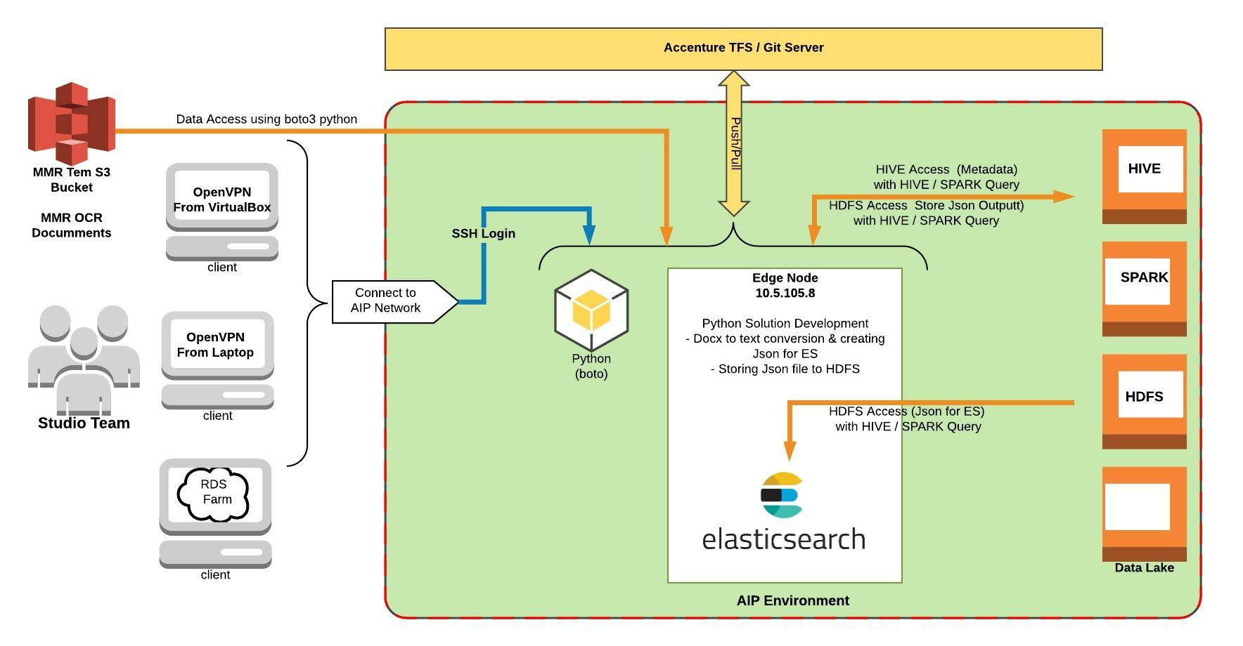
Data is prepared on the edge node for elasticsearch & and transferred to the MVP architecture to bi11.accenture.com infrastructure.
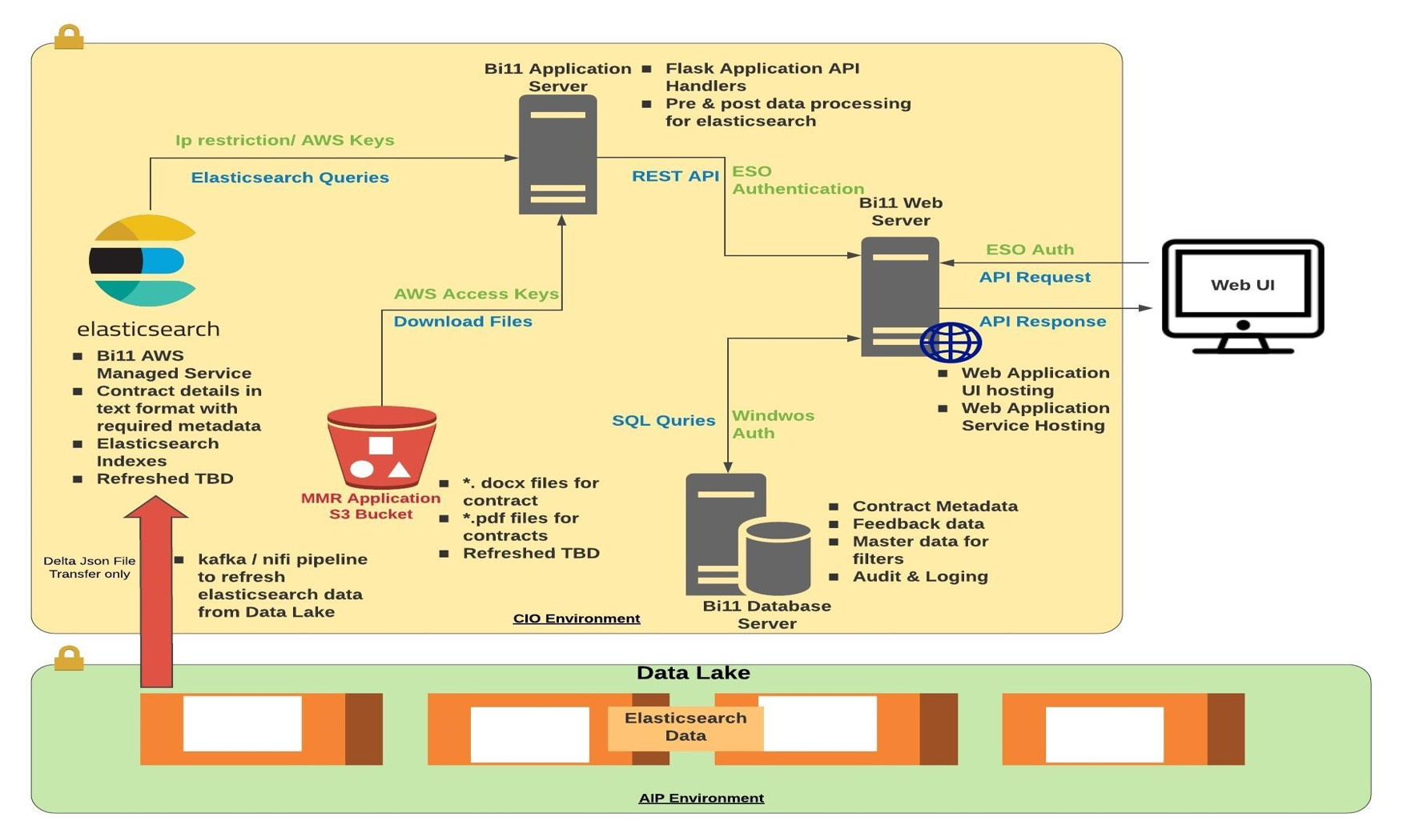
Execution Steps:
- API request is received to the Bi11 Web server
- Proxy service on bi11 web server is calling Nginx endpoint hosted on the Application server
- Incoming request is parsed in the Application server and converted to the Elasticsearch query
- Eleasticsearch returns the quey result back to the Application server followed by web server and final response is sent to the Web UI
Data Refersh:
- Manual data was transferred to the Platform with MMR metadata & contracts
- Python script was executed during MVP and prepared the Elasticsearch index data in the platform
- Elasticseach index is created manually in the execution environment for UI to consume the data
  - Kafka nifi pipleline received a blocker, hence could not complete the automated pipeline for MVP
Data Storage:
- Elasticsearch: primary storage & search engine for the project
- S3 bucket: Existing S3 bucket owned by MMR application. This is utilized to download contracts from UI
- SQL Server: Saving Audit log and UI related data including feedback data
Security:
- Please refer architecture diagram for the security layer for each endpoint.

Proposed Training Architecture
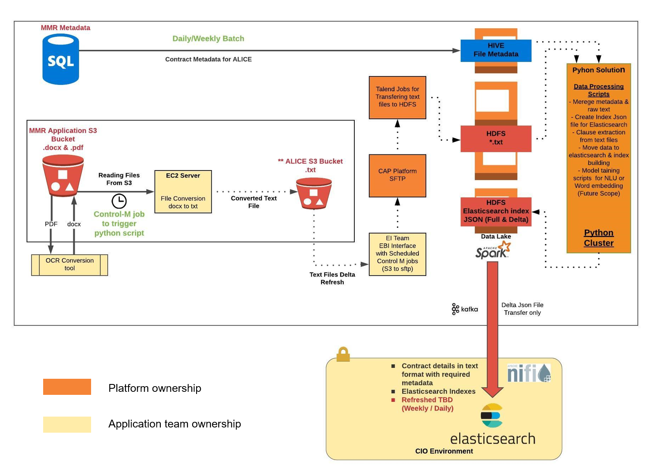
Python processing for Model training:
- Once data is ingested to the platform hdfs, python scripts will be executed from cluster for data preparations
Data Processing Scripts:
- Marge metadata & raw text
- Create Index Json file for Elasticsearch
- Clause extraction from text files
- Create josn files for Elasticsearch
- Model training scripts for NLU or Word embedding (Future Scope)
Things to Confirm:
- Ownership between for building interfaces will be more clear during onboarding process
- Timeline for Nifi to support Elasticsearch refresh with AWS Access Keys

Proposed Execution Architecture
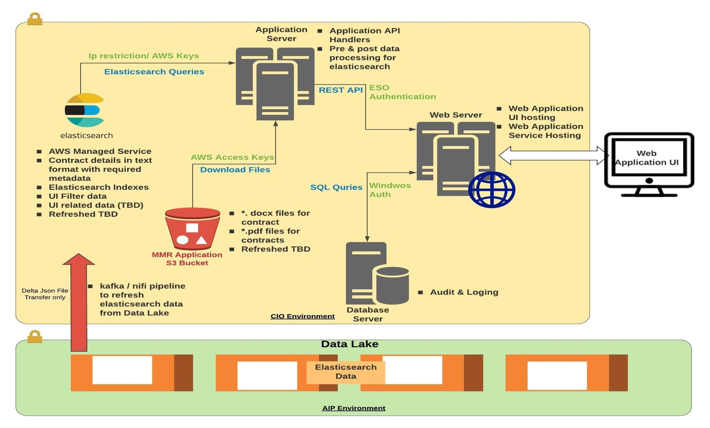
Note: Data flow is replica of the execution architecture on project dedicated infrastructure. It is expected to have automated pipeline to refresh elasticsearch index based on spark streaming job, kafka & nifi

Pre- Processing

Overview
This section explains the data pipeline for pre-processing and preparing the documents for indexing and the indexing of the processed documents. The relevant code can be found in this resitory which also contains a README with some explanation of the code and instruction on how to run the pipeline and the indexing.
Note: This explains the existing data pipeline that is based on the MVP architecture (section 2.1.2). Changes to the pre-processing scripts will need to be made by the Solution Delivery team based on the difference between the MVP architecture and the proposed architecture for Solution Delivery.

Data pipeline
The script which triggers the processing of the documents is pipeline.py. Information about running the script can be found in the README file in the repository.
We first get a list of document filepaths to be processed by the pipeline. This is done by querying HIVE for all filepaths, listing the existing filepaths in HDFS and computing the difference.
The data pipeline comprises the following stages, each of which is applied on a document and can be found in pipeline.py:
- Read .docx document from S3 bucket.
- Extract the document content in raw text.
- Extract metadata for the document from HIVE.
- Extract clauses for the document content based on a pre-trained Word2Vec model (See section 2.3).
- Combine the document content, metadata and extracted clauses in a json format.
- Save the json file into HDFS.

Index
The search functionality of this project was built on Elasticsearch 6.3 using the Elasticsearch Python client.

Documents index
When the documents have run through the pipeline we can read them from HDFS and index them in bulk. This is done by the script bulk_indexer.py and more information about running it can be found in the README file in the repository.
Similarly to the pipeline we get a list of filepaths to be indexed. This is done by listing the existing filepaths in HDFS, reading a list of already indexed filepaths from a progress file and computing the difference.
The bulk indexer reads the json files from HDFS into chunks of 100 and indexes them in bulk. A bulk indexing operation in Elasticsearch is more efficient in speed compared to indexing each document one by one. The field used as an id for Elasticsearch is “DocumentID” which is a field coming from the metadata in HIVE. This means that a document with a certain DocumentID will be created if the id is not already present in the index or updated if it is present.
It is also possible to pass in an argument for building the index (as can be seen in the README) if it is the first time running the script and this will read in the default settings and mapping for Elasticsearch and create the index before indexing the data. For more options in building, updating and deleting custom indices you can refer to the script index/indexer.py which can be used with many commands and arguments.
For a better understanding of what fields are indexed and what kind of analysis is used you can refer to the default settings and mapping for Elasticsearch which can be found under /index/es_config/. This would be the place to look at for changing any configurations related to indexing.

Permissions index
Another index that needs to be mentioned is the user permissions index. When users enter a search query in the ALICE search application their enterprise id is checked against the permissions index to see which access groups they belong to. Each document in the documents index also contains a list of access groups that determine who can view it. The permissions index contains enterprise ids and the access groups to which they belong.
We have kept a pre-built permissions index which can be updated for new users with a direct command to Elasticsearch.
Example:
We want to add two new users with the enterprise ids first1.last1 and first2.last2 to the permissions index. If we know the correct access groups they belong to we can use those. Otherwise, for users who need access to all documents but are not part of legal (e.g. testers of the application), we can add them to catch-all access groups [" ","CW.Team"].
- Create a json file “permissions_update.json” with the following content:
{"index":{"_id":" first1.last1"}}
{"enterprise_id":" first1.last1","PermissionsUpdateDate":1545381999,"group_names":[" ","CW.Team"]}
{"index":{"_id":" first2.last2"}}
{"enterprise_id":" first2.last2","PermissionsUpdateDate":1545381999,"group_names":[" ","CW.Team"]}

Note: Make sure that there are new line breaks between the commands and that there is a new line break at the end of the file. This is important because of the way the bulk indexing API of Elasticsearch works. You can have a look at their documentation here.
- curl -s -H "Content-Type: application/x-ndjson" -X POST localhost:9200/permissions_103117/Groups/_bulk --data-binary @/path_to_permissions/permissions_update.json

Clause Extraction
The relevant code for this module can be found here:
https://accenturecio04.visualstudio.com/AnalyticsPlatform_4985/_git/smart_legal_pipeline?path=%2Fsrc%2Fclauses&version=GBmaster

Introduction
The purpose of the clause extraction module is to identify passages in a contract document that reference particular clauses e.g. Force Majeure, Liability etc. These clauses may not be referenced directly. For example, a passage may not contain the words ‘Force Majeure’ but may instead contain related terms such as ‘disaster’, ‘flood’, ‘earthquake’ etc. Therefore, the clause extraction module must be able to identify related terms for the different clause types.

Approach
Related words for each clause type are identified using Word Embeddings. This involves converting words into high-dimensional vectors which facilitate comparisons between words based on vector similarity. For any word, the embedding model returns the words whose vector similarity (and therefore conceptual similarity) with that word is greatest. We can therefore use a word embedding model built on Accenture’s contracts to find terms with the greatest similarity to the different clause types.

Installation
The word embedding model is created using the Word2Vec algorithm in the Python genism package. Installation instructions for this package can be found here. The word embedding model used by the Studio was built using Python 3.5. This was required due to a compatibility issue with pyspark for Python 3.6. pyspark is required for querying HIVE tables in the data lake.

Creating the word embedding model
In order to create the word embedding model, the documents must be preprocessed by:
- Converting each document to a list of sentences.
- Using the sentence lists to identify phrases for each document.
The phrase lists are then used to create an embedding model. Code to create an embedding model can be found in the ‘CreateUSOnlyEmbeddings.py’ script. The following lines need to be changed:
- Line 68 – Change to specify a different data source.
- Line 70 – Change to specify a different data source.
- Line 88 – Change the ‘workers’ parameter. This parameter specifies how many cores should be used in training.

Using the word embedding model for clause extraction
The first step is to obtain the top related terms for each of the clause types. The clause types that will be identified in the first release are:
- COLA
- Data Privacy
- Force Majeure
- Indemnity
- Liability
- Termination
Currently, the top 20 related terms are obtained. However, related terms are case-sensitive in the Word Embedding model. For example, related terms for ‘Force Majeure’ are ‘disaster’ and ‘Disaster’. We must account for this when creating the lists of related terms. The code that performs this can be found in the ‘_get_related_terms_with_lowercasing’ function in the ‘clause_extractor.py’ script.
Each document is divided into paragraphs by splitting on ‘\n\n’ i.e. two line returns. Each paragraph is searched for keywords relating to each clause type. If a keyword is identified, its weight is added to the total score for the relevant clause type. The clause type with the highest score is determined to be the relevant clause for the paragraph. The code that performs this can be found in the ‘extract_clauses’ function in the ‘clause_extractor.py’ script.

Refreshing the word embedding model
Contract language will change over time, and the word embedding model will need to be updated to account for this change. This means that a script such as 'CreateUSOnlyEmbeddings.py’ will need to be run periodically. The Studio recommendation is that this be performed every 6 months

Evaluation
The Studio evaluation consisted of two components:
- Testing on a collection of example clauses, provided by legal SMEs. The clause extraction component was evaluated based on whether it could accurately determine a particular clause was present.
- Subject Matter Expert (SME) evaluation of the keyword lists for each clause. Based on this evaluation words are added or removed from the keyword lists.

Adding and removing words to the keyword lists
The code for adding and deleting keywords for particular clauses can be found in the ‘_update_clauses’ function in the ‘clause_extractor.py’ script.
Removing a keyword for a clause can be performed using the standard Python ‘del’ function. This can be seen in lines 198 and 199 of the ‘clause_extractor.py’ script.
There are two possible ways to add a new keyword to a keyword list:
- The keyword is already in the embedding model vocabulary. The keyword’s similarity to the relevant clause can be obtained directly from the model. The keyword and its weight can then be added to the dictionary entry for the relevant clause. This can be seen in lines 211 and 212 in the ‘clause_extractor.py’ script.
- The keyword is a multi-word phrase that is not in the embedding model vocabulary, but each of the individual words is in the vocabulary. A similarity to the relevant clause can be calculated for the phrase using the genism ‘n_similarity’ function. This can be seen in lines 214 and 215 of the ‘clause_extractor.py’ script.

Evaluation work before April release
The test set provided was quite small. This makes it difficult to reliably determine the accuracy of the clause extraction module. The Studio performed manual validation with multiple SMEs and the consensus was that the extracted clauses were generally reasonable. However, exploring ways to have a more robust evaluation could certainly be worthwhile. There are two possible ways this could be done:
- Asking representatives from the business to create a larger clause collection.
- Incorporating a feedback mechanism into the ALICE tool. This would allow users to indicate, for every identified clause, whether that clause’s label was correct.

Potential work for future releases
The following subsections describe ways in which the clause extraction module could be improved.

Determining the correct phrase length
The clause extraction module currently only handles phrases of 2 or less words. The primary reason for this is that phrases of 3 or more words may face an issue with interpretability. This raises the question of what the ideal phrase length should be. Two ways this problem could be addressed are:
- Leveraging a dictionary – A legal dictionary could be employed and the average phrase length in this dictionary could be determined.
- Extending the currently identified keywords – Keywords could be extended in order to form longer phrases. For example, a keyword for Indemnity clauses is ‘hold harmless’. This keyword could be extended to include ‘hold Accenture harmless’, ‘hold the client harmless’ etc.

Determining clause boundaries
Currently, the clause extraction module identifies clauses on a paragraph-by-paragraph basis. However, a clause may span multiple paragraphs or even pages. Being able to identify where a clause begins and ends could be a useful extension. One way this could be performed is identifying consecutive paragraphs with the same clause label. If two or more consecutive paragraphs are labeled with the same clause type, these paragraphs could be combined and returned as a single clause

Setting minimum score thresholds
Currently, the clause extraction module does not apply any minimum score threshold for identifying a clause. This means that a paragraph could be labeled as belonging to a particular clause type if only a single keyword with low relevance appears. This may result in too many paragraphs being returned. A way to address this could be to set minimum score thresholds for identifying clauses.

Bias
An important consideration when extending the clause extraction module is the possibility of language bias. Work such as Bolukbasi et al. has shown that word embeddings can capture hidden forms of bias depending on the data that is used to train them. These authors showed that embeddings trained on news documents encoded implicit bias through similarity relationships e.g. one of the closest embeddings to ‘homeowner’ was ‘woman’. While we may not expect this exact form of bias to appear in contract documents, it is possible another form of bias may be present. Therefore, for any extension of the clause extraction module that aims to leverage word embeddings, a bias check must be performed. Determining ways in which bias may appear will require SME input.

ALICE Front-End

Installation

Installation for Developers
Please follow these steps to install and deploy the front-end environment in your local machine:
- Download code from the repository.
- Open your console to execute the commands to Install related dependent packages.
  - Run the command ‘cd {your path}\alice_ui’ to change the default path.
  - Run the command ‘npm install’ to download and install the dependencies.
  - After the installation, the ‘node_modules’ folder would appear under the folder ‘\alice_ui’
  - At last, run with ‘npm start’ to start the web project and you can see the URL and the port which has been configured in the ‘package.json’ file which is under the folder ‘‘alice_ui\’ . You can certainly customize it yourself.

- Because of the cross-domain access, the developer needs to find a way to visit the Flask API in the server from the local machine. We recommend to config a proxy:
  - Firstly, add a json file ‘proxy.conf.json’ under the folder ‘alice_ui\src\config\’.
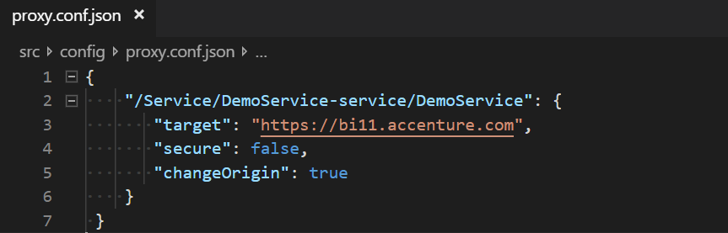
  - Secondly, add a proxy configuration in the ‘package.json’ file.
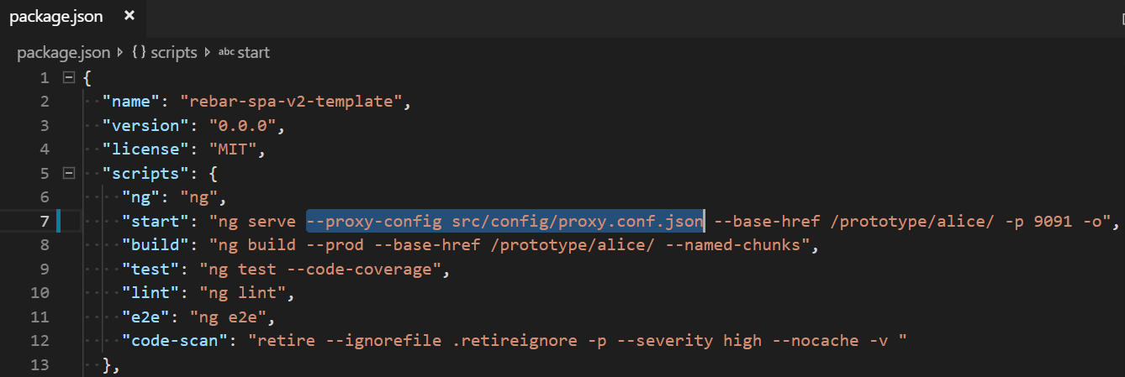
- Now the development environment is ready, you can visit http://localhost:9091 by Chrome.
- If you want to deploy ESO service, please refer to https://cioenterprisearchitecture.accenture.com/?type=CodeHub&id=137. otherwise, you should set the attribute ‘enabled’ to false in the config.json file.
- To create the files for deployment run the following command: npm run build.
It creates the “dist” (distributable) folder with all the output files for the application. This file can be then deployed to the web server under the “base-href” folder.

Developer kits
We recommend using Visual Studio Code or Visual Studio 2017 for the front-end development.

Resources

Demonstration Environment

Users need to be authorized to access this environment.
URL: https://bi11.accenture.com/prototype/alice

Repository

We recommend daily development on the branch and merge the code to the master at a specific milestone.
- Master:
https://accenturecio04.visualstudio.com/AnalyticsPlatform_4985/_git/smart_legal_ui?path=%2F&version=GBmaster
- Branch:
https://accenturecio04.visualstudio.com/AnalyticsPlatform_4985/_git/smart_legal_ui?path=%2F&version=GBfeature%2Fadjust-search

Structure Of Front-End
We referenced the REBAR SPA v2 Template (Angular 5) which is widely used in CIO to build the front-end structure. You can find the REBAR template in https://cioenterprisearchitecture.accenture.com .
There are more details here.
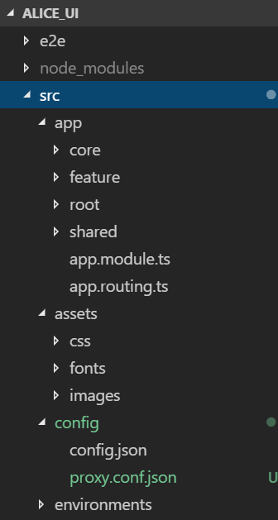
- Under the node_modules folder, there are some dependencies which includes ng-bootstrapt, bootstrap and etc.
- Under the src folder, there are some folders we need to focus.
    - All the service functions, pipes and the authentication services should be under the ‘Core’ folder;
    - Components are created under ‘feature’;
    - The root component is under the ‘root’;
    - The common components such like header and footer are in the ‘shared’;
    - ‘assets’ contains the layout and resources file;
And the ‘index.html’ under ‘alice_ui\src’ is the start page of this website.

Features

In the scope of the MVP, it involves:
- Basic Search (Search):
The user needs to input or select at least one criteria to enable the search button.
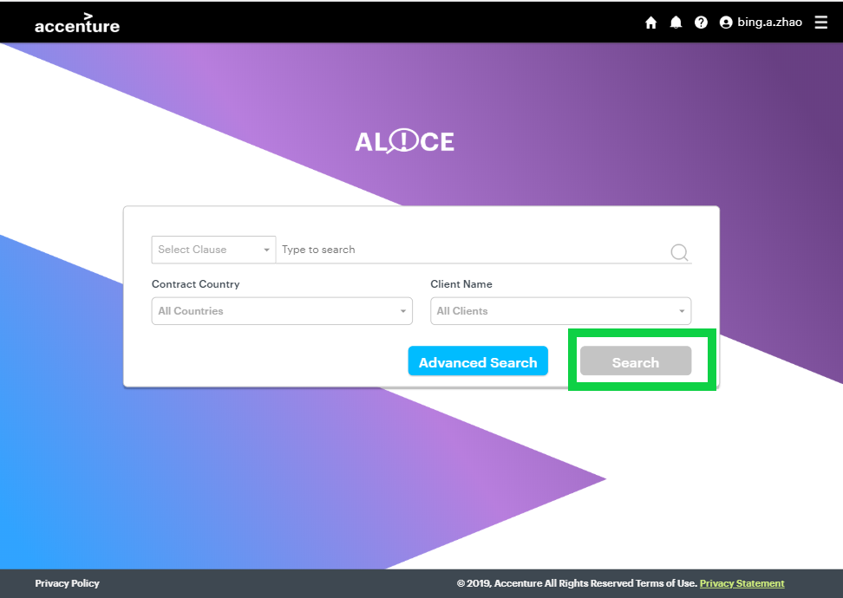

- Advanced Search:
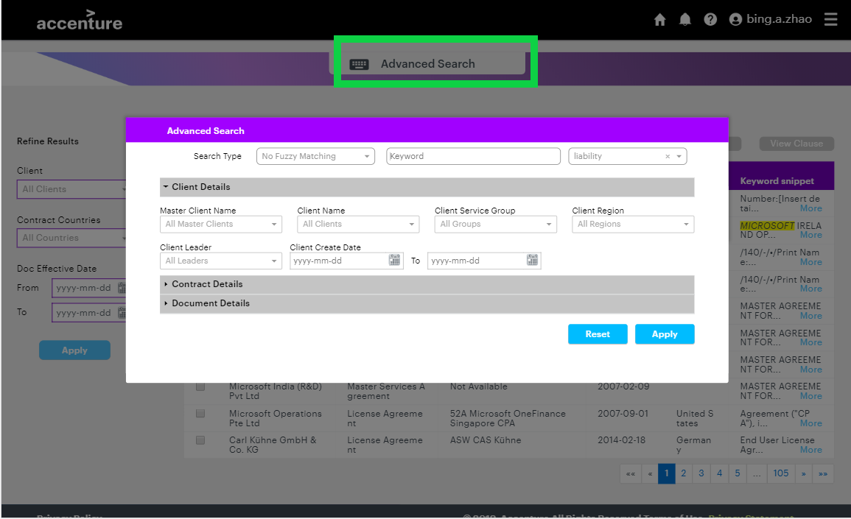

- Refine Results:
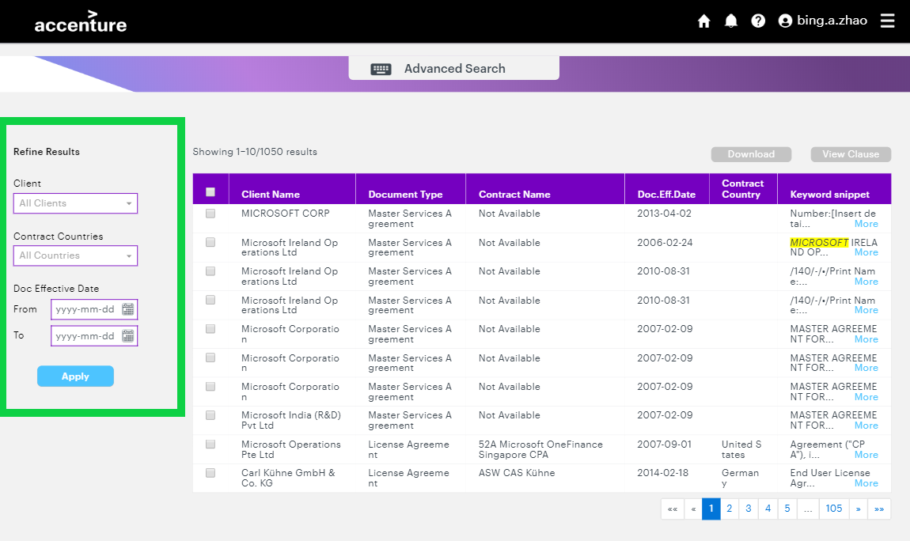
- Download documents: the user can select one or several documents to download at a time.
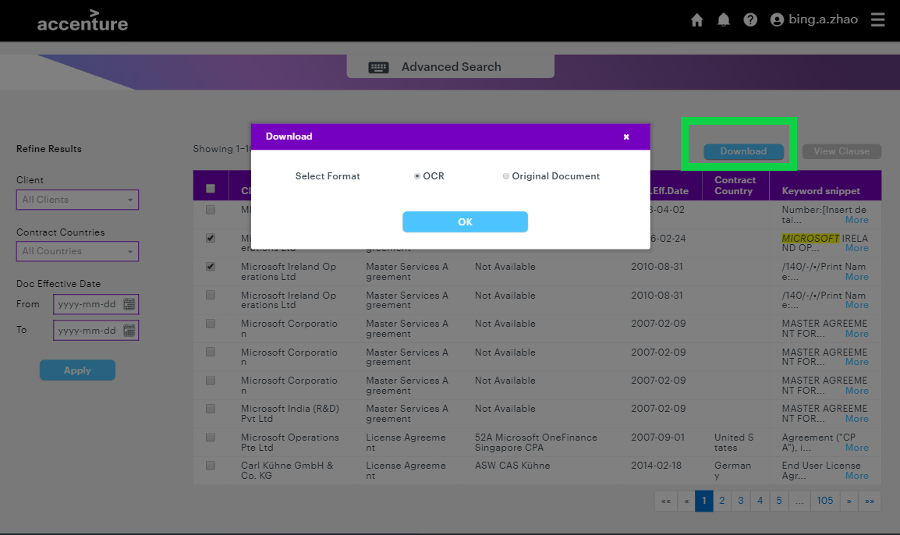
- View Clause: the user could view only one document’s clause at a time when s/he select a specific clause.
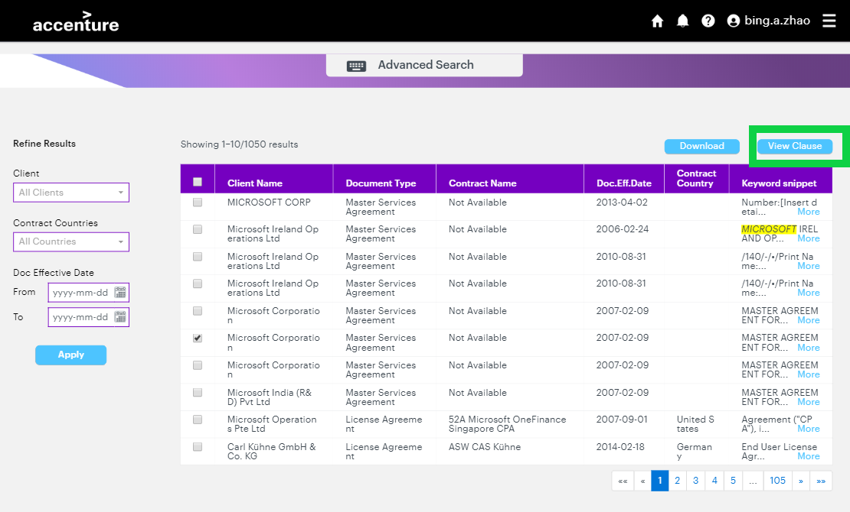
- View More about the snippet:
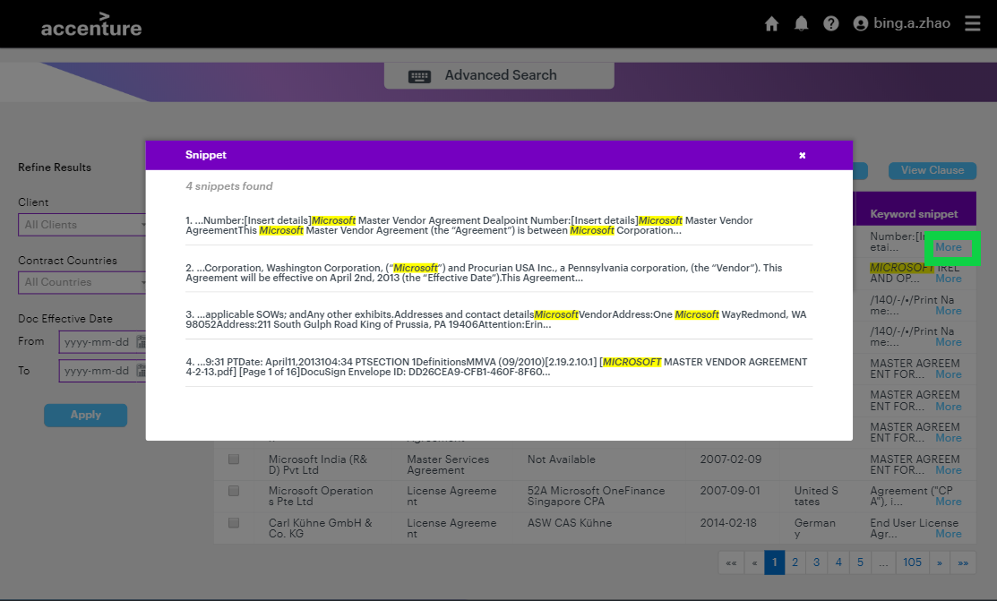
- Visit Home page (the landing page):
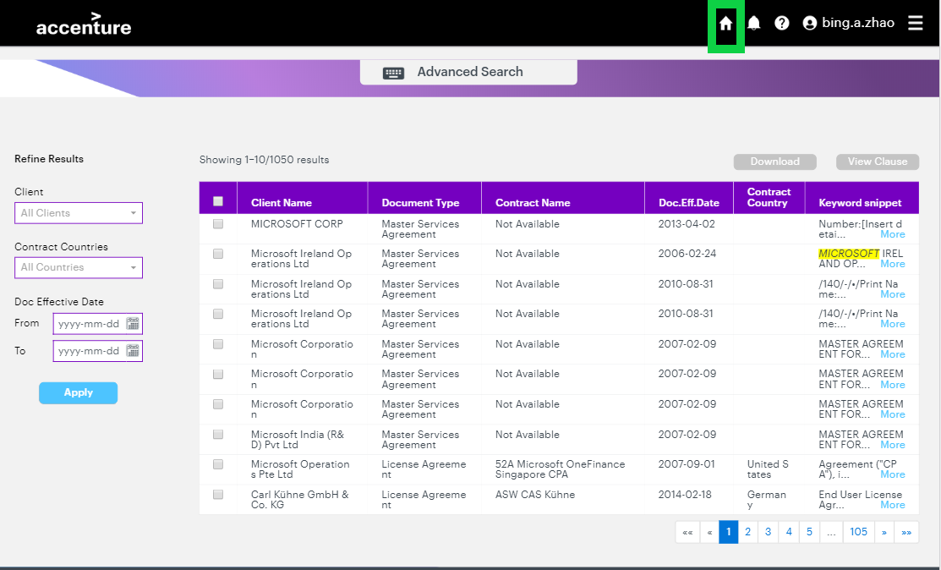

How the front-end works with API

The API is in https://bi11.accenture.com/Service/DemoService-service/DemoService which is the Master Service for all Bi11. It manages all the calls to the different models that Bi11 hosts. It’s separated from the front-end of ALICE. The application will not use Bi11 in the production environment and a new service will need to be created.
Here is the API list that we have invoked in ALICE.
- /search
- /document_content/{id}
- /download_document/{id}
- /download_document_bulk
- /get_clauses
- /values
Refer to the example below to understand how the front end works with the API.
For example, we post a request in the front-end.
this.http.post(
Url,
requestJson,
{ headers: setRequestHeader() }
)

- The ‘Url’ has been configured in the ‘config.json’ file and you can get it by this.configData.configurations.searchUrl
- In ‘requestJson’, the 'applicationid' and 'configurationname' are set by the API service.

POST:
JSON.stringify({
'applicationid': 4985,
'configurationname': 'smartlegal',
'resttype': 'POST',
'methodname': method,
'jsonpostdata': JSON.stringify(params)
})

GET:
return JSON.stringify({
'applicationid': 4985,
'configurationname': 'smartlegal',
'resttype': 'GET',
'methodname': method
});

- The 'methodname' represents the specific API function you want to call, for example ‘search’.
- The 'jsonpostdata' includes data or parameters which is needed to pass in the post request:
For example,
‘jsonpostdata’: ‘{query:"microsoft",enterprise_id:"user eid",filters:[]}’
The type of the response will be JSON.

Studio Delivery Scope and Timeline

Scope
Studio deliverables include:
- English language documents only
- Clause extraction
- Architecture design for the long – term tool
- UI including features:
  - Document search
  - Document download
  - Clause extraction
  - Advanced search

Category | Category Criteria | In Scope | Out of Scope
Architecture | Data availability, Security, Scalability and Infrastructure | - Approved Architecture Blueprints  - Delivery and support of Prototype Production architecture on Studio hosting environment. | - Delivery and operation of Production architecture on Final Product hosting environment.  - OCR automation pipeline is being investigated by the legal architecture team and is out of scope for EI.
Analytics | Full text search and Clause Extraction | - Full text search  - Clause extraction  - Blueprint for Model Maintenance. | - Continious Learning of the Model.  - Model re-Training and monitoring.
UI/UX | Functionality, Performance and User Experience | New UI will be created with:  - Clause extraction  - Advanced Search  - Keyword highlight in doc snippet  - Document download  - Clause viewer | - New UI features.  - Favorites  - Collections  - Admin user
Service Operations | DevOps, CIO Ops Acceptance, Automation | - Approved Blueprint for DevOps supporting Security Assessment and APT. | - Leading Final Product Ops Acceptance process.
Table 1 – In/Out of scope

MVP Timeline

The ALICE MVP started in October and will run until the end of January.
Figure 1 – MVP Timeline

Production Timeline

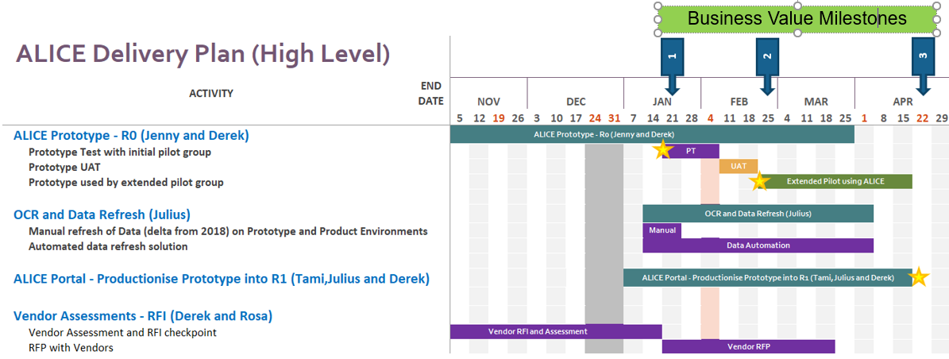
Figure 2 – High Level Delivery Plan

MVP Deployment (Project Pilot)

Project Completion

Completion checklist
ID | Task | Responsibility | Status
1 | Raw Data Pre-processing (written in python) | EI Studio | Done
2 | Create first batch of word embeddings | EI Studio | In Prg
3 | Production architecture signed off | EI Studio | Done
4 | Implement ALICE Front End | EI Studio | Done
5 | Design Model Operating and Monitoring Strategy | EI Studio | Done
6 | MVP Transition to SD team | EI Studio | In Prg
7 | Conduct Transition Sign-off | EI Studio | Not Started
8 | Solution delivery given required access | EI Studio / Platform | In Prg
9 | Feedback from Product Test shared | EI Studio | Not Started
10 | All P1 and P2 issues that are not UI related are resolved | EI Studio | Not Started

Completion Criteria
- MVP is focusing on English contracts only.
- Ability to search and find clauses in a specific contracts
- Native English language contracts
- Basic UI
- Advanced filters for contracts
- For the MVP everyone with access to the tool will be authorised to see all contracts.

Data Usage

Data overview
We used contract metadata from MMR and the content of contracts for the ALICE solution.
Limitations:
- English contracts
- Contracts created after 2011 until July 2018

Mapping between input tables for ALICE Metadata
Provided by the original ALICE team

view Name: vw_contract_documents_english
Field Name | Physical Model Mapping
ClientCountry | country.countryname for clients.country_id = country.country_id
ClientCreatedDate | clients.created_dt
ClientLeader | clients.client_leader
ClientName | clients.client_name
ClientServiceGroup | contracts.client_service_group
ClientServiceRegion | Geographic_region.region_desc
ContractCountry | country.countryname for contracts.country_id = country.country_id
DocumentEffectiveDate | contract_documents.effective_dt
ContractCreatedDate | contracts.created_dt
EngagementEndDate | contracts.contract_end_dt
ContractLeader | contracts.contract_lead
DocumentExpirationDate | contract_documents.expiration_dt
ContractName | contracts.contract_name
DocumentCategory | contract_documents.doc_category
DocumentID | contract_documents.doc_mmr_uri
DocumentLanguage | contract_documents.doc_language
MasterClientName | clients.mstr_client_name
DocumentFileName | contract_documents.doc_file_name
DocumentPath | contract_documents.doc_location
DocumentOCRPath | contract_documents.doc_dospath
MMRTopDirectory | Contract_documents.mmr_top_dir
ALICETopDirectory | Contract_documents.alice_top_dir
DocumentLoadDate | contract_documents.mmr_load_dt
DocumentUpdateDate | contract_documents.mmr_updt_dt
AccessGroups | List of locations aggregated for document based on the document access

Transition Communications

Intended Message | Cut off Date | Method of Communication | Date of Communication
Studio team will officially finish the project at the end of Feb | 31/01/2019 | Team internal communication | 23/01/2019

Communication with PO/Stakeholder
Communicate Sign Off to all stakeholders and interested parties
Intended Message | Method of Communication | Date of Communication
- PO/Stakeholders should be aware of project progress;  - PO/Stakeholders should know | Meeting/Emails

Transition Activities Agreed
Including workshop, KT sessions.

Approvals
The Signatures of the people below relay an understanding that all the activities handled as part of the EI Studio Project are complete and the project has been formally signed off the transition.

Position/Title | Signature/Printed Name/Title | Date
Product Owner
Product Stakeholder

Appendix

Presentation and Stakeholder Slides

Technical Report and Blog

MVP Code Repository
All code is stored in TFS

Author of different sections
1.1 Business Summary – Jenny McCarthy
2.1 Architecture Design – Pranay Sanjay Shah
2.2 Pre-Processing – Anna Kostekidou
2.3 Clause Extraction – Aonghus McGovern
3 Studio Delivery Scope and Timeline – Jenny McCarthy
4 MVP Deployment (Project Pilot) – Jenny McCarthy
5 Project Completion – Jenny McCarthy
6 Transition Communications – Jenny McCarthy
7 Approvals – Jenny McCarthy

Based on SME feedback, keywords related to ‘liability’ were overly broad. Therefore, for liability clauses, we use keywords related to the phrase ‘consequential damages’.

